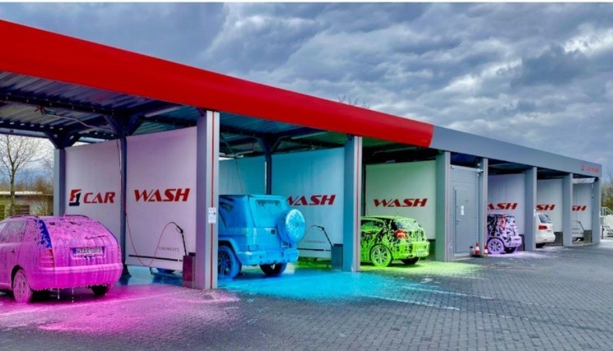**Tiba Swiss International العالميه سويس طيبه شركه** General Contractor Company

Car Wash Touch Free T.S.I 204

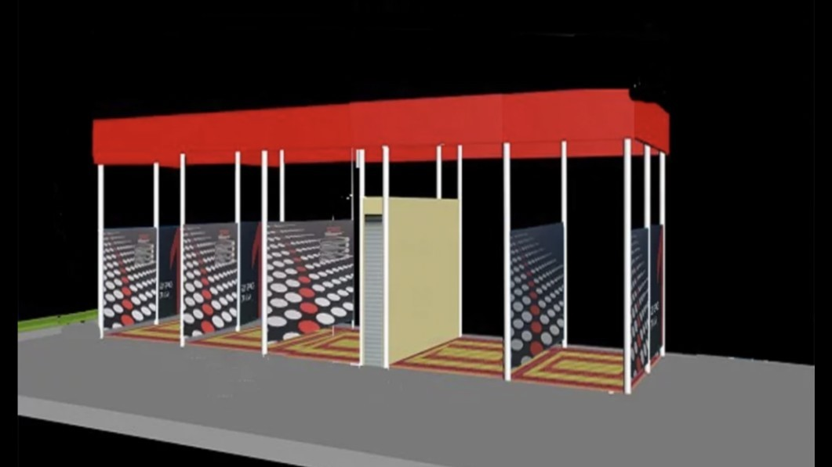

Schlosslistrasse 2

2504 Bie/Bienne

Tel. +41763435938

[info@tibaswiss.ch](mailto:info@tibaswiss.ch) [www.tibaswiss.ch](http://www.tibaswiss.ch/)

**فوائد الغسيل اآللي washing automatic of Benefits**

تحافظ علي السيارة car the Maintain

نظافه اكثر للسيارة clean the for clean More توفير الوقت فقد خمس دقائق minutes five only time Save الوقايه من الصدأ للسيارة prevention rust Car صديقه ومحافظه علي البيئه proof maintain and Friendly سهوله الدفع واالستخدام use and payment of ease of الغسيل في اي وقت time any at Laundry

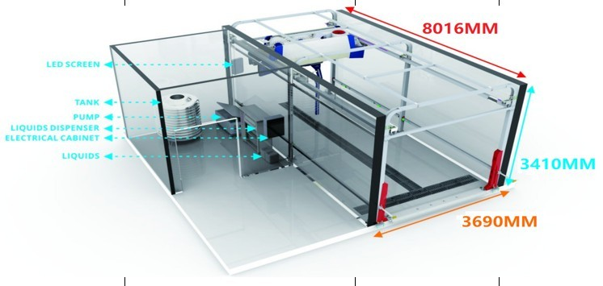

**معلومات تنبيه عن 204 T.S.I Data Technical**

|  |  |  |  |
| --- | --- | --- | --- |
| **No.** | **Function Descriptions** | **Brand Details** | **Remarks** |
| **(1)** | **Water Protection Level is IP67** | **Taiwan Delta servo motor**  **Sino-Intlund waterproof air-drying motor**  **Sino-Intlund waterproof air-drying motor**  **Taiwan Delta servo drive system Taiwan Delta**  **LCD screen Pepperl+Fuchs Alemania P+F ultrasónico**  **Pepperl+Fuchs P+F Photoelectric Sensor**  **Japan Omron Relay French Schneider Contactor**  **taly New Dotz Liquid Dosing Pump**  **Hot dipped galvanized steel frame**  **High strength**  **416 stainless steel nozzle** | **Germany pinfl Japan NSK**  **Germany PEPPERL+FUCHS**  **France schneider Taiwan Delta Taiwan Delta**  **Germany PEPPERL+FUCHS** |
| **(2)** | It can display a variety of car |
|  | wash modes, parking |
|  | indication, fault display, status |
|  | display, etc. |
| **(3)** |  |
|  | Accurately sense the body |
|  | position, |
|  | determine the cleaning range |
| **(4)** |  |
|  | Precisely control the amount of |
|  | foam, colorful leave-in solution, |
|  | and coating water wax |
| **(5)** |  |
|  | 1.Thickness up to 4mm, |
|  | 2.Q235 international standard, |
|  | 3.salt spray test grade ten |
|  | 4mm,Q235 |
| **(1)** | **HP-260 Type (Touchless 360 car wash)** | **HP-260 (STANDARD)** | **Specifications: Model** |
| **1.1**  **1.2**  **1.3** | **Descriptions / Touchless 360 car wash**   1. **Intelligent unmanned systems** 2. **Smart 360 technology.** | **LXWXH=3300mm*1100mm*1000mm LXWXH=8180mm*3680mm*3500mm LXWXH=2500mm*1600mm*2000mm**  **3 Phase 380 V 50HZ**  **Max:18.5kw;max working:18.5kw 70-120Bar** | Machine dimensions INSTALLATION SPACE SUPPLY STATION  Main power Total power Water pressure Air supply Vehicle type  Wash size |

|  |  |  |  |
| --- | --- | --- | --- |
| **1.4** | **3. Intelligent chemical mixing** | **car/SUV/Coatch within 10 seats** | Wash speed |
|  | **system.** | **LXWXH=2300mm*2500mm*2050mm** | Power consumption |
| **1.5** | **4. Innovative suspension** |  | chemicals |
|  | **system non-resistance rails** | **Quick wash:3'12" , Premium** | consumption |
| **1.6** | **5. Unique embedded fast** | **wash :5'12"** | **water consumption** |
|  | **drying system** | **0.65kwh** |  |
| **1.7** | **6. Digital voice security alarm** | **7ml/12ml** |  |
|  | **system** | **165L** |  |
| **1.8** | **7. Faulty self-checking system** |  |  |
|  | **8. One key anti-frozen system** |  |  |

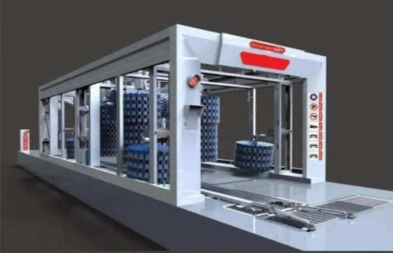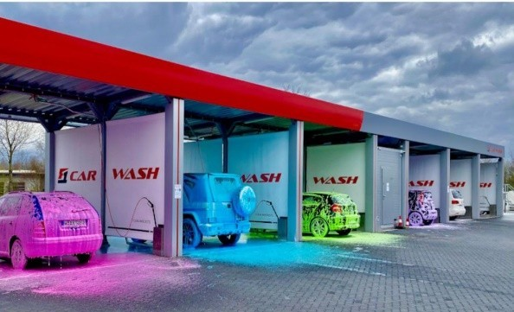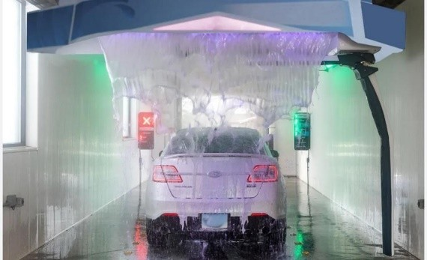

شركه طيبه سويس العالميه General International Swiss Taiba للتجاره العامه والمقاوالت Company Contracting and Trading

**Schlösslistrasse 2**

**2504 Bie/Bienne**

**Tel . +41763435938**

[**info@tibaswiss.ch**](mailto:info@tibaswiss.ch)